

**ANALYSIS OF FLOWLINE- RELATED sPILLS**

**January 1, 2019 – December 30, 2019**

**Prepared by:**

**Colorado Oil & Gas Conservation Commission**

**1120 Lincoln Street, Suite 801**

**Denver, CO 80203**

**Table of Contents**

Annual Review of Flowline-Related Spills 2

Global Root Causes 2

Figure 1. Reported Causes of 2019 Flowline Releases 3

Table 1. Root Causes of Flowline-Related Spills in Each County 5

Table 2. Root Causes of Flowline-Related Spills in Each Basin 5

Table 3. Principal Root Causes of Flowline-Related Spills in DJ Basin 6

Common Preventative Measures / Corrective Actions 7

Corrosion Failure 7

Incorrect Operation 7

Equipment Failure 8

Natural Force Damage 8

Pipe, Weld, or Joint Failure 8

Excavation Force Damage 8

Figure 2. Flowline and Non-Flowline Related Spill Reports Submitted 9

Flowline Spill Reporting Over Time 9

Unknown Root Causes 9

Table 4. Operators with Unknown Root Causes 10

Gathering vs. Non-Gathering 10

Operator History 10

Table 5. Highest Number of Reported Flowline Spills (top 10 operators) 10

# Annual Review of Flowline-Related Spills

For the 2019 calendar year, 247 spills related to flowlines were reported in Colorado. Just over 18% of the reported spills were historical releases. In this report, historical release volumes were not included in the review due to the difficulty to estimate accurate values. Fifteen percent of reported spills had unknown root causes because the Form 19 (or its supplemental documentation) either did not contain enough information to determine the cause, or a root cause had not yet been submitted. Unless explicitly stated, the unknowns have not been included in this analysis. Also any spills explicitly reported as gas gathering lines are not included in the dataset.

# Global Root Causes

Operators have become more aware of the importance of submitting detailed root causes and mitigation measures on spill reports. Eighty-five percent of the flowline-related spills reported for 2019 were submitted with detailed root causes. The root causes were classified in the following categories:

* **Corrosion Failure:** leak caused by galvanic, atmospheric, stray current, microbiological, or other corrosive action. Includes external and internal corrosion
* **Natural Force Damage:** leak caused by outside forces attributable to causes NOT involving humans, such as earth movement (not related to improper compaction at install), earthquakes, heavy rains, lightning, thermal stress, or other similar natural causes.
* **Pipe, Weld, or Joint Failure:** leak resulting from a material defect within the pipe, joint due to faulty manufacturing procedures, design defects, or in-service stresses such as vibration, fatigue and environmental cracking.
* **Other Outside Force Damage: l**eak resulting from outside force damage, other than excavation damage, such as damage by car, by drilling rigs, man-made as primary cause of incident. Also includes, animal-made incidents.
* **Excavation Force Damage:** leak resulting from outside force damage caused by activities related to excavation
* **Equipment Failure:** leak caused by malfunctions of control and relief equipment including regulators, valves, meters, compressors, or other instrumentation or functional equipment.
* **Incorrect Operation:** leak resulting from inadequate procedures or safety practices, or other operator error. It includes leaks due to improper valve selection, installation, operation or inadvertent over pressurization

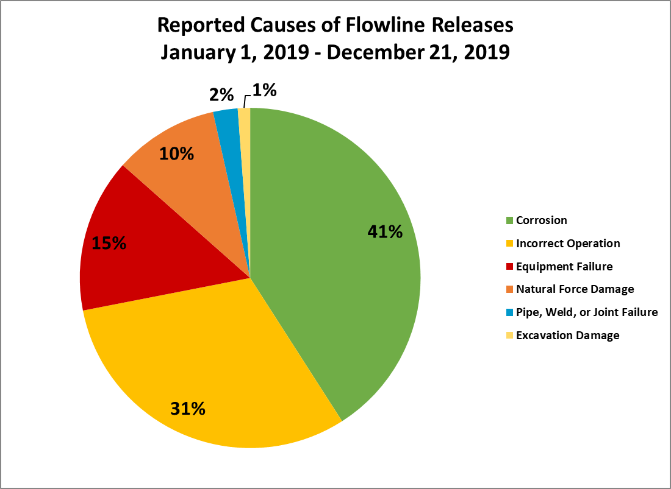

Figure 1. Reported Causes of 2019 Flowline Releases

Corrosion, incorrect operation, and equipment failure represent 86% of the root causes of flowline related spills. This analysis will focus on those four root causes.

Approximately 41% of the spills were caused by corrosion. Of the 70 spills reported with corrosion as a root cause, 39 were due to internal corrosion, while 17 were due to external corrosion, and 14 were unknown.

The largest portion reported of corrosion failures (46%) were observed in the Denver Julesburg Basin; 7 (22% of DJ corrosion subset) from Noble Energy Inc. However, in the Piceance, Caerus represents 19% of all corrosion failure flowline reported spills for Colorado (13). This accounts for half of the spills in the entire Piceance. Lastly, Chevron represents all of the corrosion-related spills in the Douglas Creek Arch (8), which is lower than corrosion reporting from even the first half of 2018 (10).

Incorrect operation accounts for 31% of the spills. These spills were split between the following: valve misalignment (22), improper installation (16), inadequate procedures (13), and overpressure (2).

The highest reported incorrect operations (57%) occurred in the DJ with (6) of those spills from Highpoint. However, in the Piceance (25% of incorrect operations subset), Laramie Energy accounted for 7 of those spills.

Equipment failures were also significant for 2019, making up 15% of all flowline-related spills. TEP Rocky Mountain had the highest number of equipment failures (4/25). Three of four of these failures were due gasket failures and likely due to age of these wear items.

Natural force damage represents 10% of the flowline-related spills. The majority of those were reported in the DJ, but XTO in the Piceance actually had the highest of this failure mode (3) of any operator. PDC and Chevron also had a pair each in the DJ and Douglas Creek Arch respectively.

Pipe failure only represents 2% of the failures for the year. All four cases were outside of the DJ. Two with Timber Creek and one with Evergreen in the Raton. The remaining one was with Chevron.

Excavation force damage was only reported for 2/171 flowline-related spills. Both occurred in the DJ, one on a KP Kauffman line and one on a Kerr McGee line.

See below for a summary of the apparent causes of flowline-related spills classified per basin and per county. Note that these do include the Unknowns in the tables, so the following three tables with differ from the above analysis.

## Table 1. Root Causes of Flowline-Related Spills in Each County



Table 2. Root Causes of Flowline-Related Spills in Each Basin

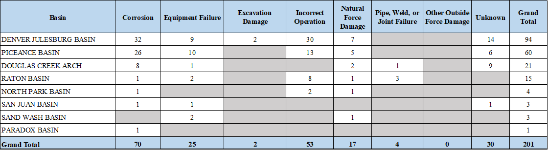

The highest frequency of the flowline-related spills are located in the DJ Basin (47%) and Weld County (38%); followed by Piceance Basin (30%) and Rio Blanco County (16%). It is representative of the amount of Oil and Gas activities in those regions.

Below is a summary table representing the Denver Julesburg Basin, Weld County with the three most common root causes in the county.

## Table 3. Principal Root Causes of Flowline-Related Spills in DJ Basin



# Common Preventative Measures / Corrective Actions

## Corrosion Failure

Some operators have taken steps to prevent spills caused by corrosion by replacing the damaged sections of pipe or the entire line. Most of the reported internal corrosion were located at along the pipe rather than fitting or bends. In the Piceance Basin, Caerus reported eight internally corrosive leaks. In most cases the piping had to be replaced and was pressure tested before being placed back into operation. Given the high number of occurrences of this failure mode, Caerus noted on multiple forms that they are evaluating their field-wide chemical treatment program. In addition to treatment, one promising preventative measure is “All existing dumplines will be replaced with corrosion-resistant stainless steel lines.”

In the DJ basin, Bonanza reported release of 25 bbl of produced water when the dumpline failed. None bbl of the released produced water was recovered. Bonanza Creek continues to note their chemical treatment program is in use, but it may require revisions based on the high occurrences of internal corrosion.

Also in the DJ, Highpoint had an external corrosion failure. The failure was specifically a dumpline from a separator to a storage tank. For corrective action they stated “The line was replaced prior to being brought back online. Water dump lines of similar vintage and history being replace throughout the field.” This is a highlight for an operator to commit to using the data they have on pipe vintage to replace at the end of the observed lifespans.

In the Douglas Creek Arch, Chevron had many instances of corrosion failure. Historically Chevron has had the Corvel-coated pipe has been the main source of internal corrosion. Chevron continues to replace those failed sections with stainless. The largest release was 90 bbl of produced water with 80 bbl of the release recovered.

Some operators are replacing uncoated carbon steel lines by Fusion Bond Epoxy coated pipe to protect against corrosion, even opting for double coating where internal corrosion is an issue. Uncoated pipe came up on several occasions, so retrofitting older vintage infrastructure as a preventative measure could pay dividends. Another common practice is to replace flex steel or carbon steel piping that is venerable to corrosion with fiberglass or poly piping. Stinging larger diameter steel pipe with smaller spoolable pipe continues to be a simple solution especially for longer length replacements. KPK used this solution in a ~1200 ft. trunk line feeding four wells in Dacono.

## Incorrect Operation

In the Raton basin, Evergreen Natural Resources had five separate releases due to incorrect operation. Two of the five were valve misalignments and three were improper installation. Both the valve misalignments were during tank loading activities, so easily correctable with proper training and supervision. This supervision is critical to avoid one of these instances that led to a 120 bbl spill, of which only 3 bbl were recoverable.

For the installation issues, the padding in the trench seemed to be the issue. Considering modern pipeline construction practices call for avoiding angular rock in both padding and backfill, there should not be an issue with the replacement pups moving forward.

The highest number of incorrect operation failures for 2019 resides with Highpoint. This is an operator that included neither a detailed root cause description, nor corrective action in the relevant supplemental form 19’s.

## Equipment Failure

As stated above, TEP Rocky Mountain had the highest number of equipment failures and primarily due to gasket issues. Their method of prevention is to increase their gasket inspection interval and specifically putting the responsibility on pumpers prior to equipment usage. However, in one case a rubber gasket was used in a high-pressure application. This led to a 130 bbl spill, TEP’s 2nd largest of the year. In addition to more thorough inspections of older items TEP is looking to use properly-rated equipment for more critical applications.

Another operator with a equipment failure was Highpoint. In this case, Highpoint’s heat trace system failed and ultimately let to a freeze failure on a water line. While spill volume was not reported, the operator indicated the need to inspect yet another piece of ancillary equipment in the future.

## Natural Force Damage

XTO had three natural force damage spills totaling 367 bbl of produced water, but all was recovered. In two of the three, line freezes were the cause. The solution provided by XTO is to use heat trace in these situations. XTO’s one valve freeze will also utilize heat trace moving forward.

PDC’s natural force damage spills included one with 182 bbl of oil and 67 bbl produced water. PDC noted a change to routine inspections on oil tanks. This is to reduce venerability of hydrocarbon fittings not usually exposed to the seasonal water freezing conditions

## Pipe, Weld, or Joint Failure

All four of the pipe failures were with joint fusions. After repair, Timber Creek offered testing prior to returning these lines to service. This is convenient as it is in lockstep with our current 1100 ruleset for returning lines to service.

## Excavation Force Damage

Utility locating procedures are to be reviewed to identify actions to reduce recurrence. KP Kauffman noted that their line strike occurred on a fiberglass line. For their fiberglass assets, this is especially troublesome for locates. At the very least, they plan to pressure test before returning to service.

Kerr McGee reported the other excavation damage. A release of at least 1 bbl of condensate that occurred at a gathering line when the line was struck during excavation activities by a third party. For mitigation, oversight of utility locating activities by third party contractors as well, prior to initiating subsurface work.

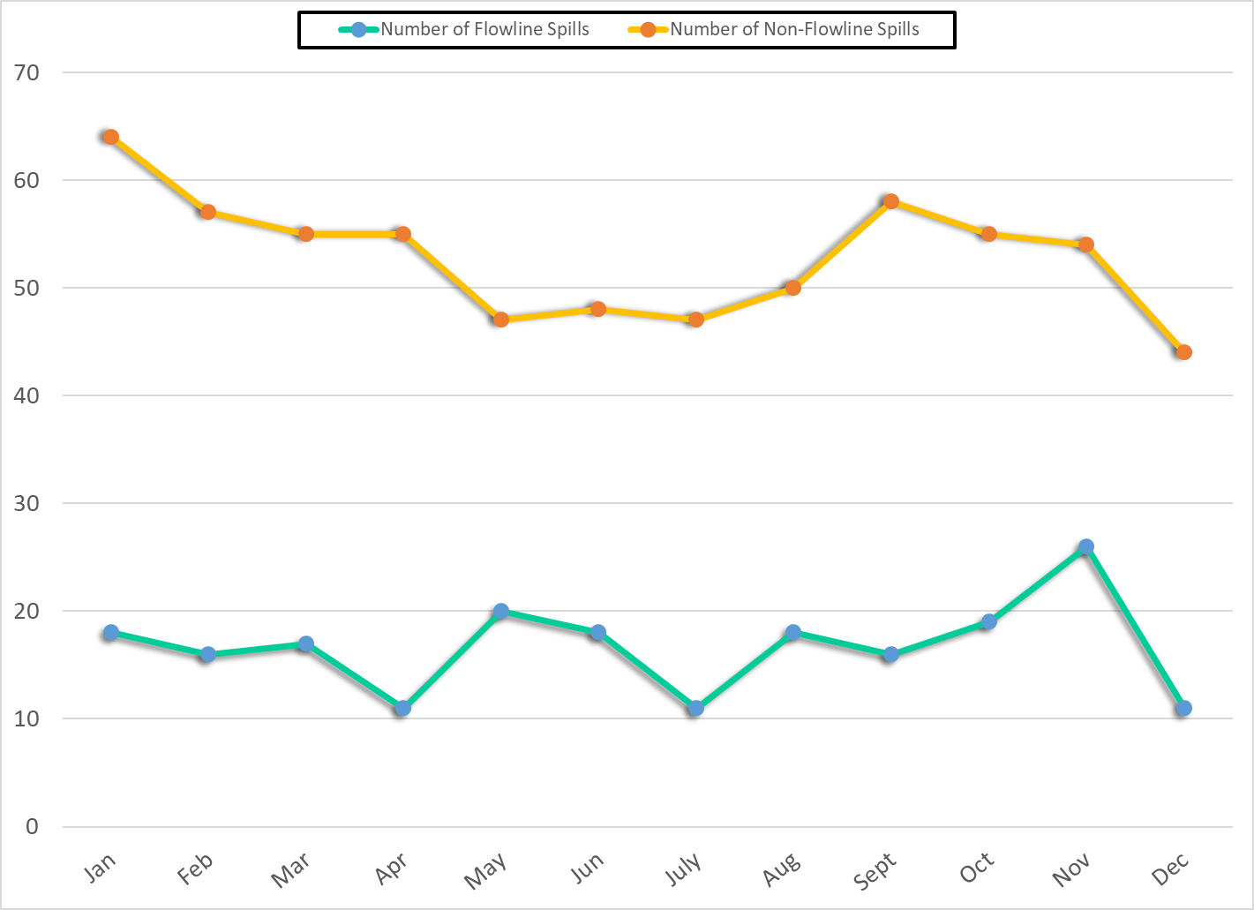

## Figure 2. Flowline and Non-Flowline Related Spill Reports Submitted

# Flowline Spill Reporting Over Time

Comparing all of 2018 to 2019 (including the unknown root causes), the spill count stayed consistent at 203 vs. 201. As a part of the Flowline Audit process, the Integrity Group reviews spill reports previously submitted by operators, inquires about root causes, and encourages operators to provide more detailed root causes if necessary. The Integrity Inspectors conduct flowline inspections on locations across the state when spills are reported and when repaired lines are pressure tested. Environmental Protection Specialists have also encouraged operators to submit root causes before closing out spill reports. Below are the final summaries related to unknown root causes and the highest reporting operators (for flowline-related spills).

# Unknown Root Causes

Chevron's unknown root causes are in Rio Blanco county.  Six of the unknown-cause spills are associated with their injection lines.  All three of Whiting’s are in Weld, one of which was stung with a liner.

## Table 4. Operators with Unknown Root Causes



# Gathering vs. Non-Gathering

Of the spills in this report (including unknown root cause), 8% were noted as a gathering line. The remaining 92% were not explicitly reported as a gathering line.

There was some reporting of gas gathering leaks. As previously noted, these were not included in the data set.

# Operator History

Spill data was analyzed to determine which operators reported the most spills, and which operators reported the largest spill volumes. The top operators of total spills are listed below. When reviewing this data, keep in mind that some operators have a larger number of active wells.

## Table 5. Highest Number of Reported Flowline Spills (top 10 operators)

